PRESS RELEASE
August 1, 2013

Please post on your Calendar of Events and include in your announcements of happenings around town.

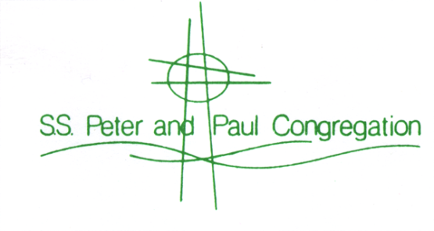
“The Heart of Christ in the Heart of the East Side”

The Eddie Butts Band Headlines
Saints Peter & Paul Block Party
September 14, 2013.

This Milwaukee East Side neighborhood festival is close enough to home to call your own, and it’s free and open to the public. This mid-September festival is just the ticket to end a busy summer. Located in the 2400 block of N. Murray Avenue, the festival begins at 2pm with children’s games and Murray’s Marketplace. Colin O’Brien with his Bluegrass/Folk Music hits the stage from 3pm - 6pm while you enjoy some of the last festival food of the season.

Gypsy Geoff, circus entertainer, strolls the grounds from 5pm - 7pm, with his free show at 6:15pm. Don’t let your kids miss his show. It’s mesmerizing entertainment for both children and adults. Face painting and crafts are also available from 2pm - 7pm in the Family Fun area.

Stay for The Eddie Butts Band from 7:30pm - 11:00pm. Take advantage of this unique opportunity to see Eddie Butts in a casual atmosphere with no cover charge. Burgers, our famous festival Brats, and homemade Desserts await you. Wine, Lakefront Brewery beer and Colectivo Coffee (Alterra) are available all day.

One lucky raffle winner will receive $1,000 cash, and First Prize is an iPad®. Other raffles include cash prizes and gift baskets. And our ever-popular HUGE Silent Auction returns from 2pm – 9pm, with Dining, Sports, Entertainment, Collectibles and MORE – it is one of the best you will find! Don't miss all of the fun, music, food and drink.

For a complete schedule of events, visit http://www.ssppmilw.org/blockparty or email us at SSPPBlockParty@yahoo.com.

S.S. Peter and Paul Congregation
2491 N. Murray Avenue
Milwaukee, WI 53211
414/962-2443
http://www.ssppmilw.org/blockparty

"the Heart of Christ in the Heart of the East Side"

